Government College Women University Faisalabad

Submitted to:
Ma’am: Sadia Saher
Submitted by:
Aima Nasir (23126)
6th MC
Bs Computer Science
Object oriented analysis & design



Exercise (Sequence Diagram)
1. ATM System – Withdraw Cash
- The user inserts their ATM card into the machine.
- The user enters their PIN for authentication.
- The system verifies the PIN and grants access.
- The user selects the withdrawal option and enters the amount.
- The system checks the account balance.
- The system dispenses cash if sufficient funds are available.
- The system updates the account balance and prints a receipt.
-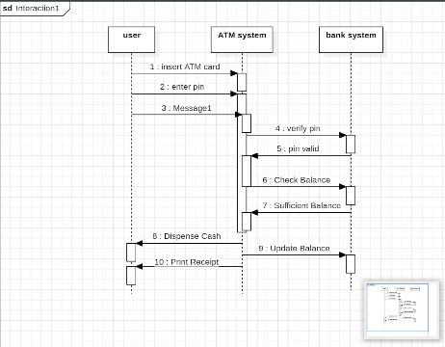
2. Online Shopping System – Place Order
- The customer browses products on the platform.
- The customer selects items and adds them to the cart.
- The customer proceeds to checkout.
- The system requests shipping and payment details.
- The customer confirms the order and makes payment.
- The system processes the payment and confirms the order.
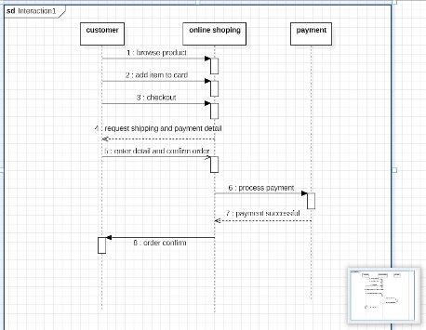

3. Ride Booking System – Book a Ride
- The user enters pickup and destination locations.
- The system displays available drivers and fare estimates.
- The user selects a ride and confirms the booking.
- The system assigns a driver to the user.
- The system notifies both the driver and the user.
- The ride is tracked until completion.
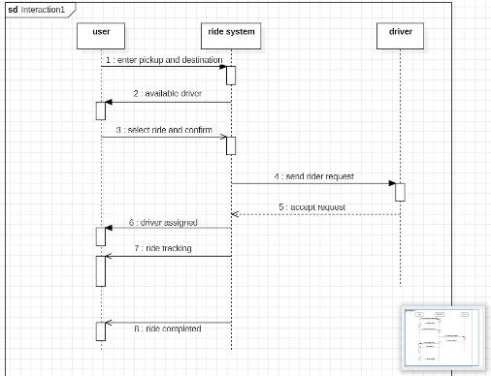
4. Hospital Management System – Book Appointment
- The patient logs into the system.
- The patient searches for a doctor by specialty.
- The patient selects a suitable time slot.
- The patient submits the appointment request.
- The system checks availability and confirms the booking.
- The patient receives appointment confirmation.
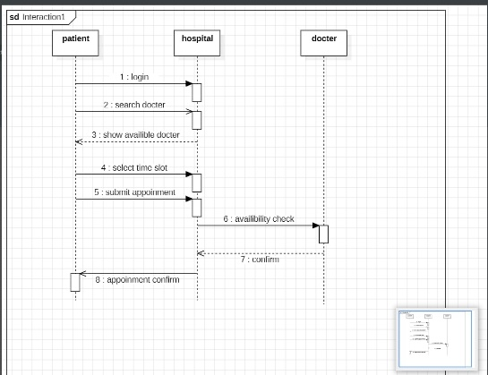

5. Movie Ticket Booking System – Book Ticket
- The user selects a movie and showtime.
- The system displays available seats.
- The user selects preferred seats.
- The user enters payment details.
- The system processes the payment.
- The system generates and sends the ticket.
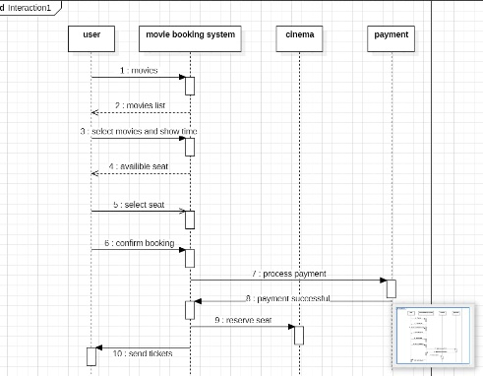
6. Food Delivery System – Order Food
- The user browses restaurants and menus.
- The user selects food items and adds them to the cart.
- The user confirms the order and makes payment.
- The system sends the order to the restaurant.
- The system assigns a delivery rider.
- The user tracks the order until delivery.
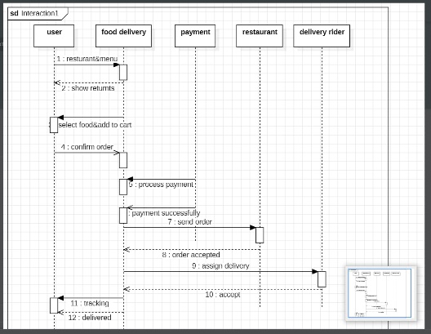

7. Payroll System – Generate Salary
- The HR manager enters employee details.
- The system calculates salary based on rules.
- The system includes bonuses and deductions.
- The HR manager verifies the data.
- The system generates payslips.
- The system processes salary payments.
